How to use service of distribute file server:

1. Run initservice.sh to initiate the service, load the database.
2. Put your files in the client folder

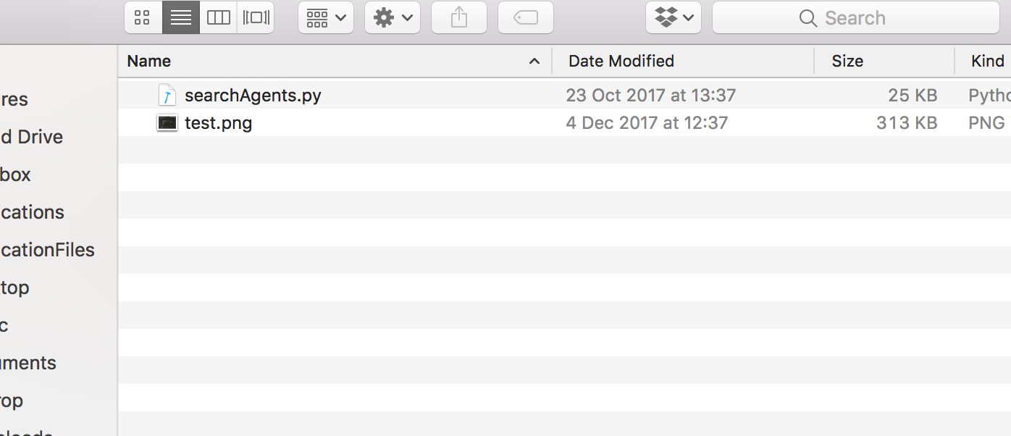

1. Open the client.py and input command and filename to upload or download files. You can create multiple clients to upload multiple files.

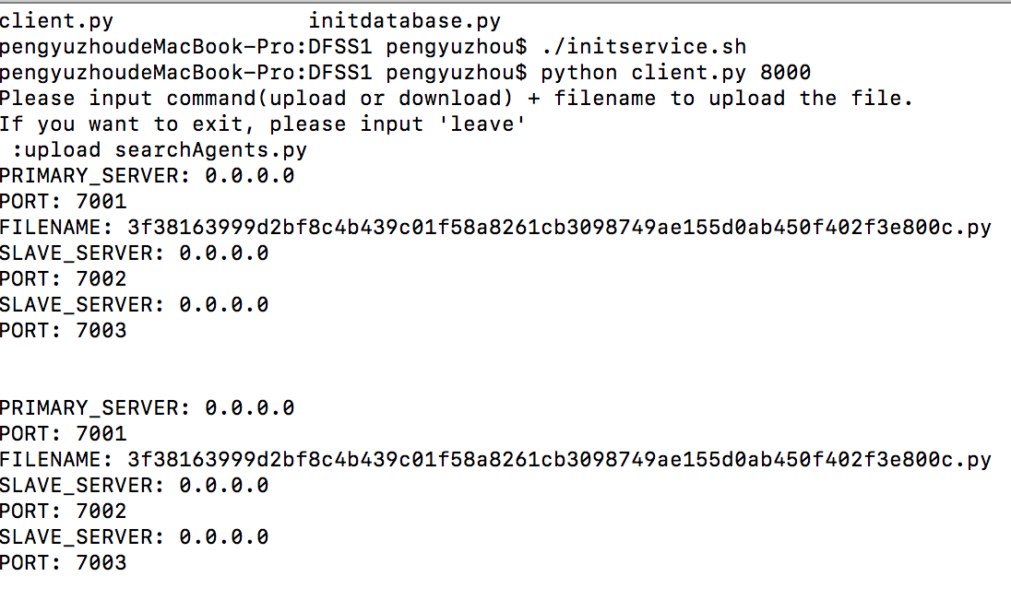

*upload files*

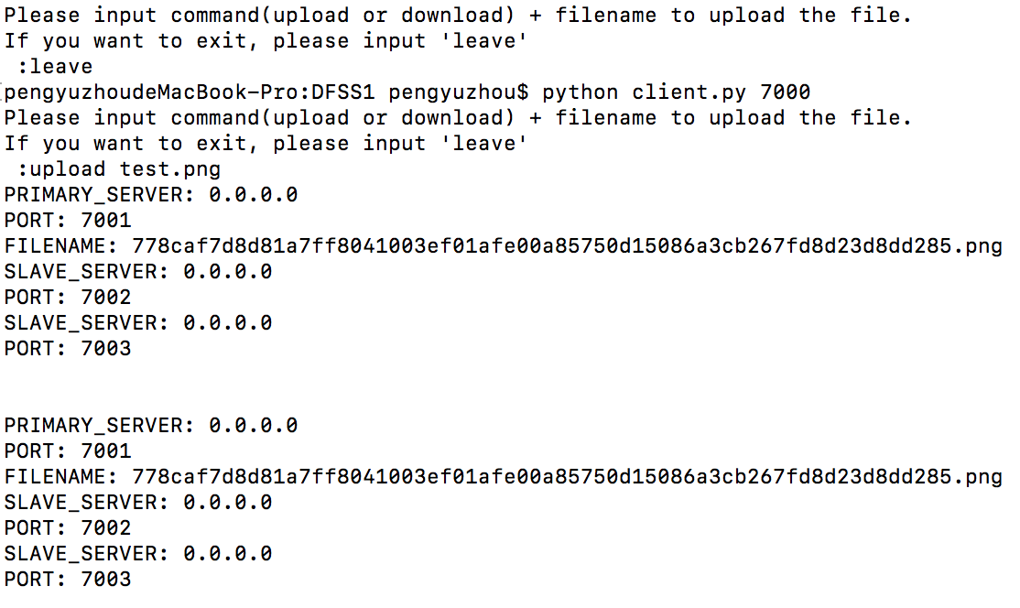

1. Directory service: we could return certain file location by returning the server information.

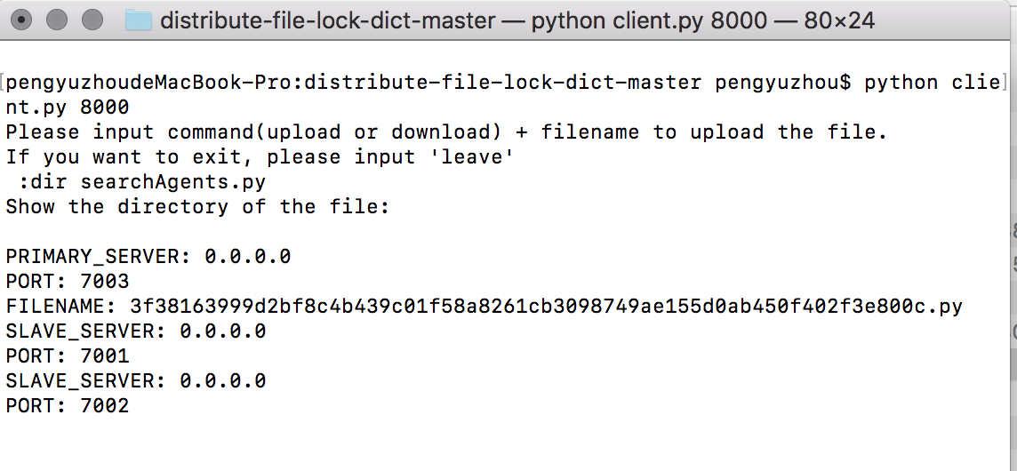

1. lock service: we partially implemented the lock service in our program. But the service is still not working.

